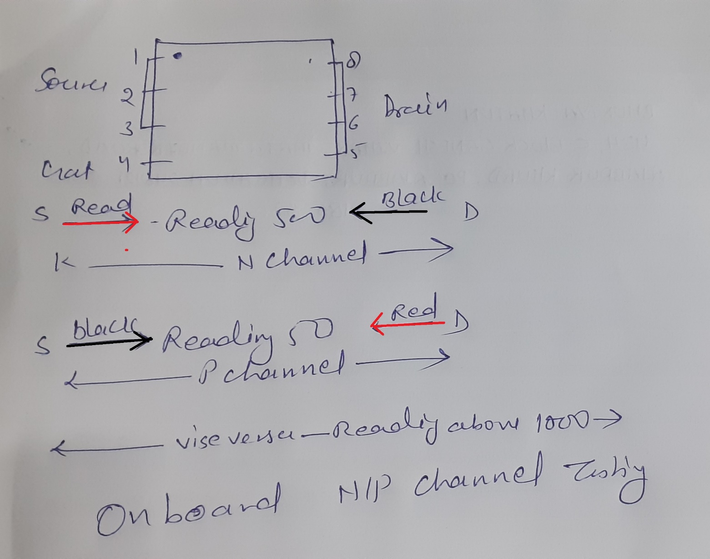
https://www.youtube.com/watch?v=OTiUeA55CU4&list=PLovJQ6y8UZAQqvTsprlixcTyDmhPfOK2C&index=4

